CST2355 – Database Systems Lab Assignment 4

Student Name: Nouraldin Hassan

Student ID: 041054019

Student email: hass0443@algonquinlive.com

# Hand-in:

1. The lab assignment will be graded out of a maximum 4 points.
2. This template should be used to submit your lab assignment.
3. Make sure you have enough screenshots to completely document that you have completed all the steps.

# Activities (Steps):

In this lab, you will be using the Microsoft SQL Server Management Studio (and connecting from MS Access)

1. First you will use SQL Server Management Studio to create a new database that is owned by your own personal account by performing the following tasks:
   1. You need to enable remote connections using SQL Server username/password authentication. Do the following:

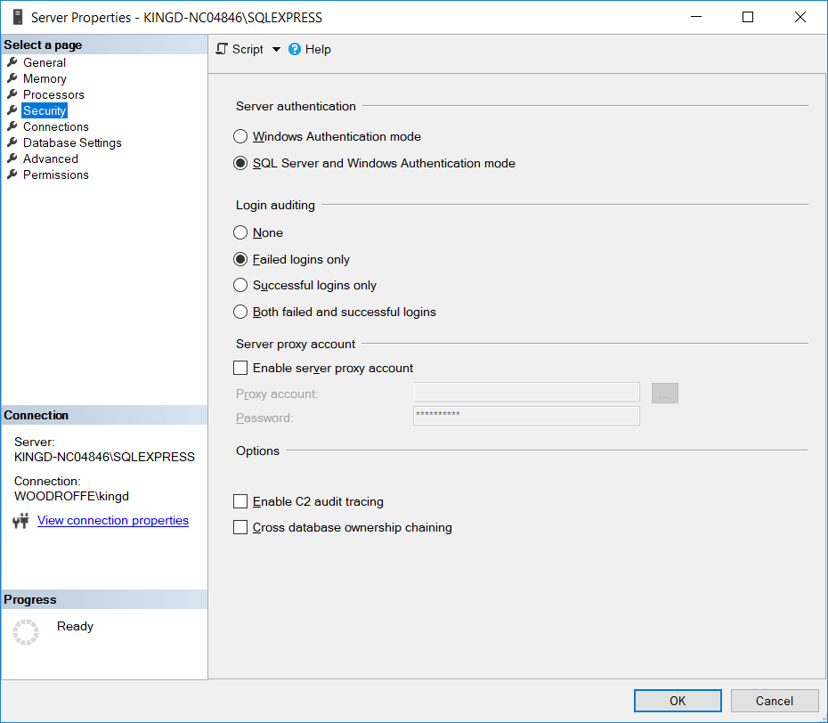

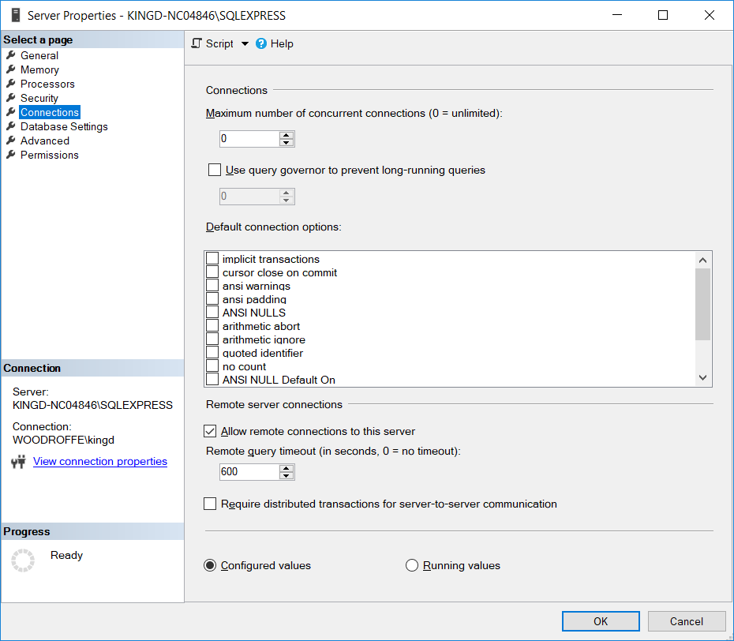

* 1. Now, create a new login named “*yourlastnameLogin”* (e.g., kingLogin). (under Security > Logins in Object Explorer). This is mine:

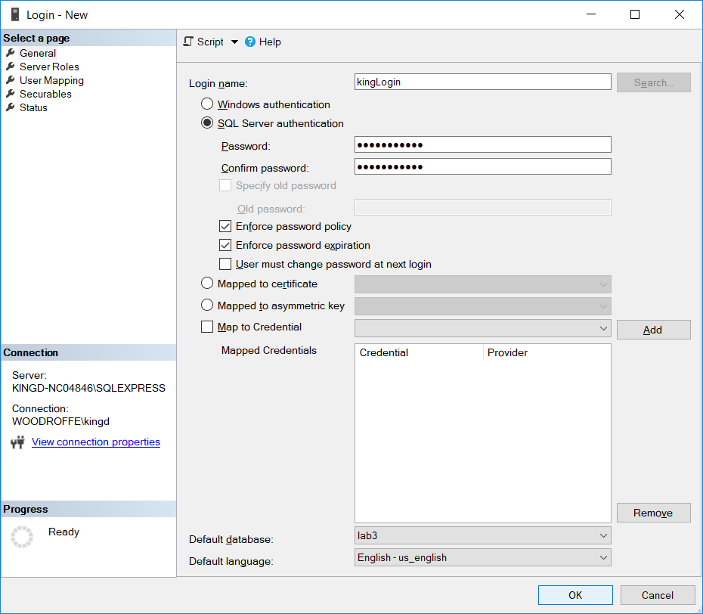

Provide a screenshot showing the unselected “User must change password at next login”, your selection of SQL Server authentication, the default database as lab3, and the default language as English.

Paste your screenshot here:

* 1. Create a new database called “lab4”, with the owner specified as *yourlastnameLogin* (your new login).
  2. Create a new schema in the lab4 database, named “lab4EmployeeData” and set it as owned by the built-in “dbo” database user. (The owner of the database).

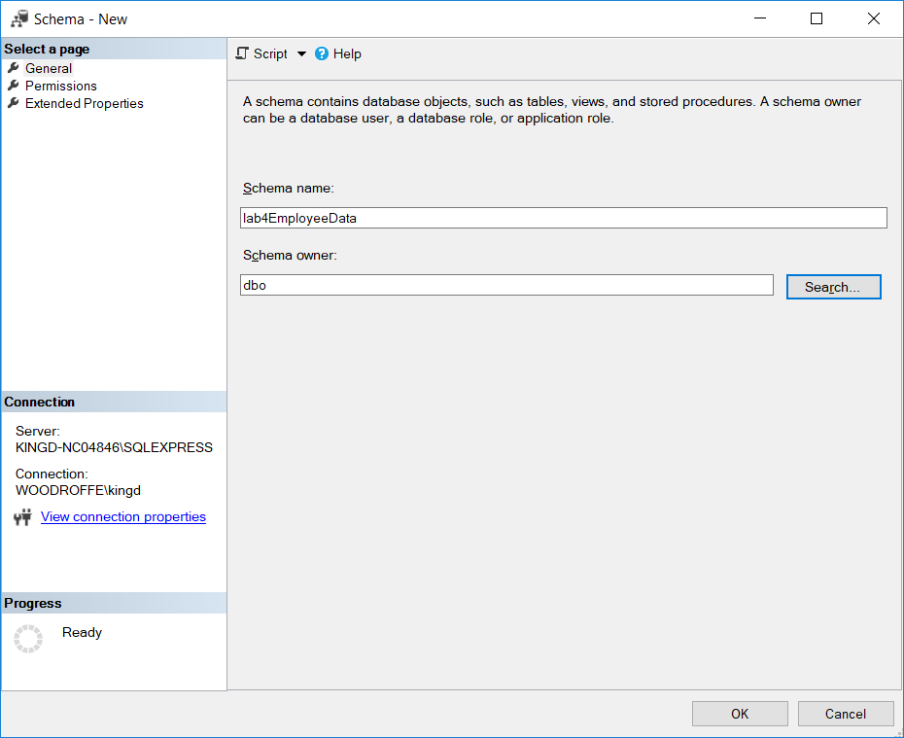

* 1. .Modify your new login id to have “lab4” as the default database instead of “lab3”.
  2. Create the following tables in lab4, as copies of the tables in lab3 by doing these steps:
     1. Do Employees first:

(Use: “SELECT * INTO lab4.lab4EmployeeData.Employees FROM lab3.dbo.Employees”)

* + 1. Then: Departments, Roles, Hobbies, and the hobby-related table(s) that you will need to run your MS-Access reports later (those that were used.to get the Employee Roles Book and the Employee Hobbies Book.)
    2. Connect to SQL Server from SSMS using your new login and then run select statements to verify that the data has been copied correctly.

Show the login results below (with screenshot that shows the connection):

1. Now that you have the data copied over to the new database, we will create the relationships using the Diagram editor:
   1. First, give yourself permission to do this: under Security > Logins, open your Windows login profile (NOT the one that would have remote access). You should see something like this (with less privileges selected):

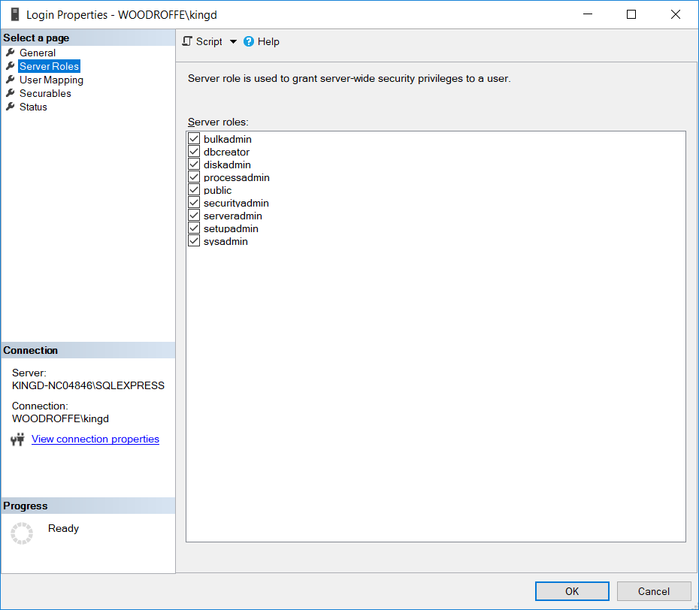

* 1. Add all the privileges that you might ever need (e.g., all of them). You need at least serveradmin privileges.
  2. Now create a new database diagram by right-mouse clicking on “Database Diagrams” under lab4 in the Object Browser.
     1. Add each of the tables in lab4EmployeesData to the diagram.
     2. Use the diagram interface to set the primary keys for each table.
     3. Once the keys are in place, add the foreign key relationships **for each of the foreign key relationships** using the diagramming interface as follows for each relationship. (Careful – for the many-many relationship between employees and hobbies, you will need to add more than one relationship (one for each of the foreign keys in the physical table containing the relationship data).:
        1. Select the field containing the foreign key in the table (this is the table to which the constraint will be attached) Right-mouse click the field and select “Relationships…”
           1. “Add” a new relationship

In the pop-up select “Tables and columns specification”. Then a button containing ellipses (…) to the right will appear – click on it to run the dialog.

Select the corresponding primary key (linked) table and field

* + 1. Save your diagram as “lab4EmployeeDataDiagram” and provide a screenshot of your resulting diagram: (here is mine)

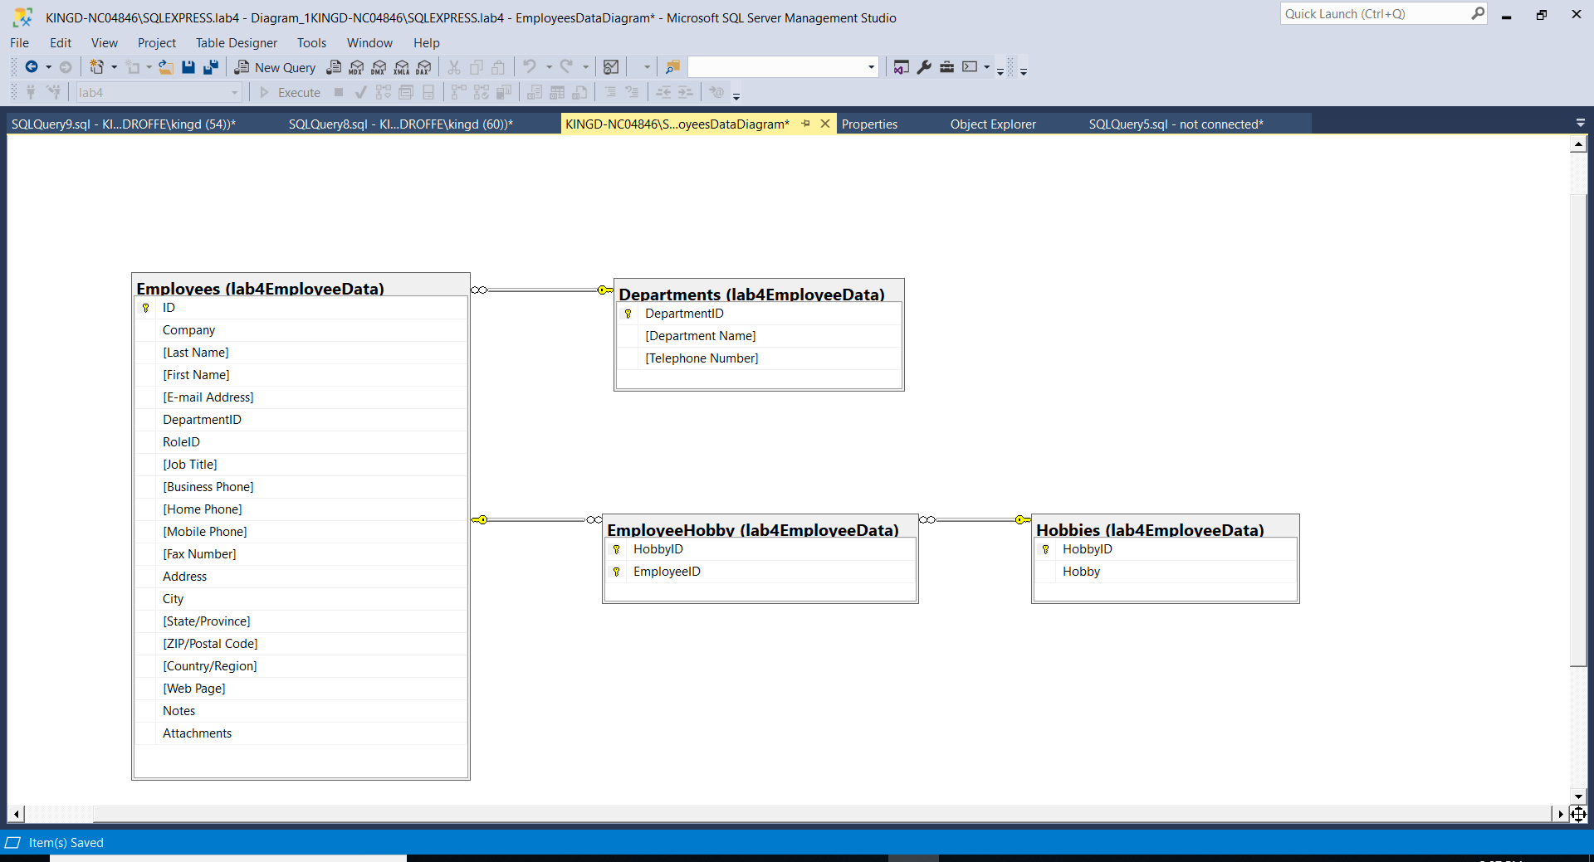

Paste yours here:

* 1. Save your database and all your work

**Note:** **The following two Steps (Steps 3 and 4) both add an ODBC data source for your new database. Step 3 does it using the windows ODBC Data Source Administrator tool (likely 64 bit); while in Step 4 it is done from Access (either 32 bit or 64 bit). Depending upon your versions installed, the dialogs may be slightly different. Depending upon your version of Access installed (32 bit vs. 64 bit) BOTH steps may be necessary in this course. If it seems repetitive, just continue and create the second DSN. You may end up with one 32bit and one 64bit connection; or with two 64 bit connections from which to choose.**

1. First, we will create an ODBC data source for your new database.
   1. Open the ODBC Data Source Administrator tool in Windows:

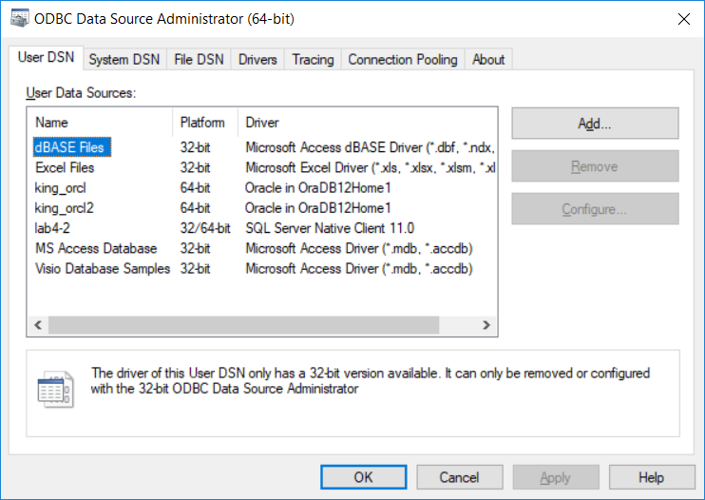

* 1. And then Click Add

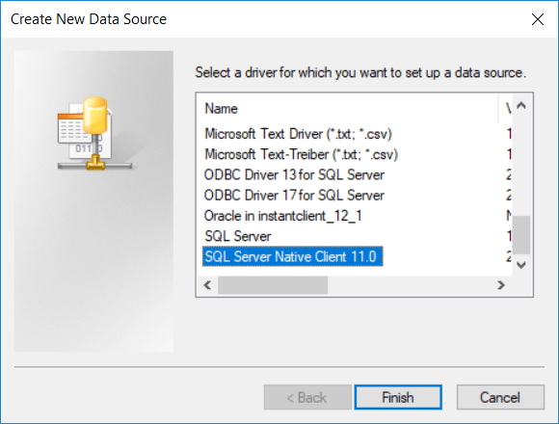

* 1. And Select the SQL Server Native Client 11.0

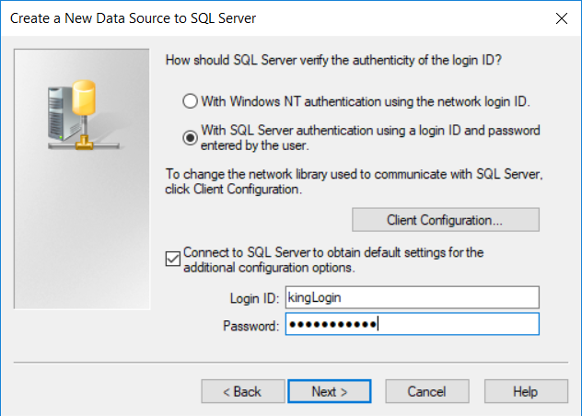

* 1. Continue with the configuration, and make sure that you test your connection at the end.

Provide your successful connection test here:

Note: We went though the process together

1. Now we will open Microsoft Access, use the built-in dialogs to launch the ODBC manager (32 bit or 64 bit depending on which version of Access is installed) and connect to the new database using our new ODBC DSN, as if it were a remote database!
   1. First make a copy of your lab3 database and store it as lab4.accdb. We will use the new copy.
   2. Open the lab4.accdb file.
   3. Under the “External Data” menu, select the “ODBC Database” icon from the ribbon.
   4. Then specify that you want to “link” to the external data rather than copy it.

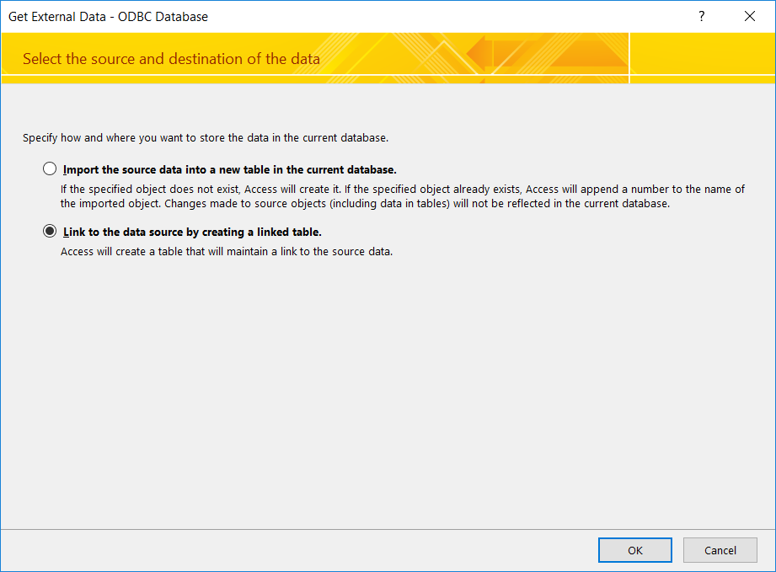

* 1. Select User DSN: and then select “Add”.

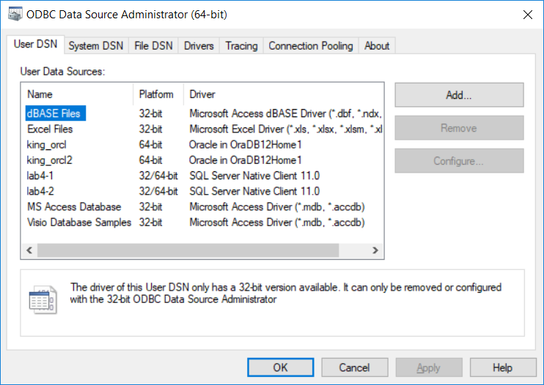

* 1. Select “SQL Server Native Client 11.0” and click “Finish”:

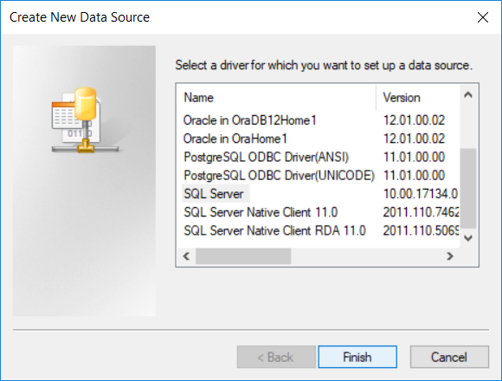

* 1. In the pop-up, give your new data source a name and enter the SQL server that you would like to connect to (See lab 3 for your server name):

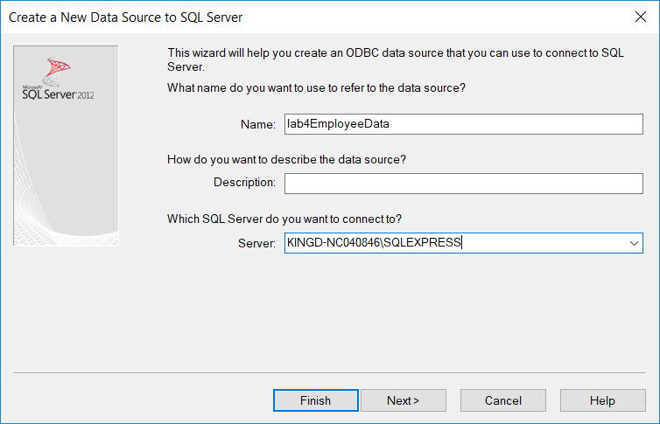

* 1. And provide your login/password on the next screen:

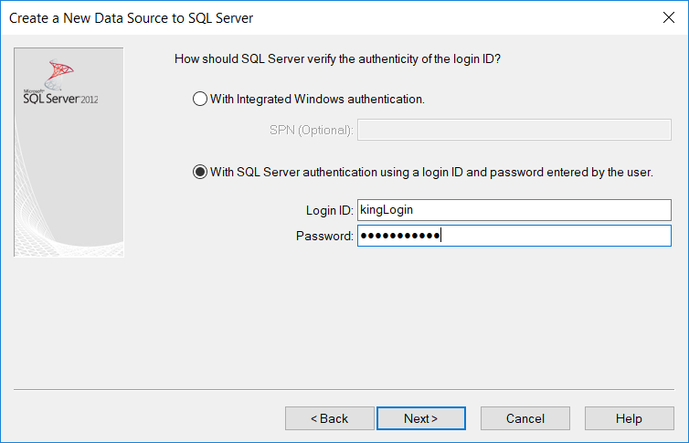

* 1. And change the default database

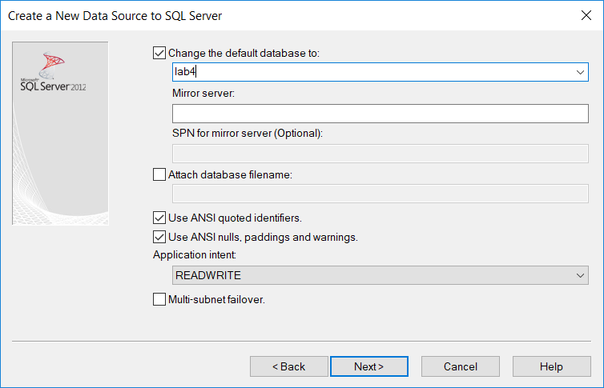

* 1. NOTE: In the resulting pop-up, the connection parameters are listed. It is important that you test your new database connection, so click on “Test Data Source”. With confirmation similar to:

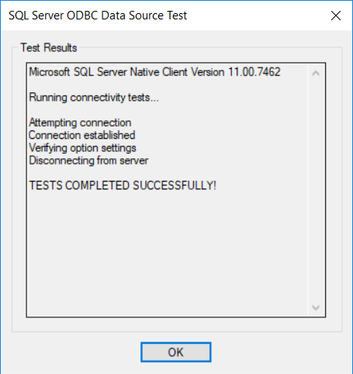

Paste your successful test confirmation here:

Note: We went through this together, test was successful.

1. Now that you have the DSN for our new database ready, we can use it to link to the shared tables directly from Access.
   1. Create a new table linked to the external ODBC SQL Server Source by doing the following:
      1. Use the “External Data” menu in Access and select “ODBC”.
      2. Then create a **link** to the table (do not import a copy), and when prompted, select your newly created ODBC DSN from the list of Machine Data Sources and click OK. Then supply your login/password.
      3. You should be prompted with a list of tables visible to that user. Select only the tables from lab4EmployeeData and then create the links. (You may be prompted for keys….)
      4. Once complete, the tables will be available in Access – for use and/or update.

Provide a screenshot showing the links to the lab4EmployeeData tables:

Note: the tables circled in red have been imported for this step.

* + 1. Now do an update from Access:
       1. First, go to SSMS and run a query to list all hobbies as currently in lab4.lab4EmployeeData.Hobbies:

Paste your screenshot here:

* + - 1. Update the hobby name for one of the hobbies by editing the value in the “Open” link in Access:

Paste your screenshot here:

Note: HobbyID 9 previously said “Writing”

* + - 1. Re-run the SSMS query to show all hobbies as now in lab4.lab4EmployeeData.Hobbies (it should be updated!):

Paste your screenshot here:

1. Create a new report using the Access report wizard to show the list of hobbies for each employee, grouped by employee. The report should use the data from the newly linked tables that are actually stored in SQL Server.

Provide a screenshot of your report here:

1. Once you have embedded all of your screen shots, submit the file in Brightspace and you’re done!